The Personal And Social Attributes Of Emotional Intelligence
Godfrey Ouma
University of the People
PSYC 1205: Emotional Intelligence
Lisa Buch
April 18, 2024

The Personal And Social Attributes Of Emotional Intelligence
I choose self-awareness as my personal and social attribute of emotional intelligence. There are varying definitions of the term self-awareness depending on the scholars’ point of view. Carden, Jones, and Passmore (2021) conducted a systematic literature review to explore the varying definitions of the term self-awareness in the context of adult development. To sample four definitions of self-awareness from their findings, Feize and Faver’s (2019) definition: “Self-awareness simply means awareness of self and is not limited to time; it is ever-present and occurs constantly. Everyone has the capacity to focus on the ‘self’: however, this capacity is not always used.” Lawrence et al.’s (2018) definition “Self-awareness is conceptualized as the extent to which individuals are consciously aware of their internal states and their interactions with others.” Rasheed et al.’s (2019) definition “Self-awareness is an evolving process of self-discovery, which means self-awareness is dynamic and ever-changing and it never achieves saturation.” Finally, Sutton’s (2016) definition: “Self-awareness is a conscious awareness of one’s internal states and interactions with others” (Carden, Jones, & Passmore, 2021, p. 147-153). There is no one-size-fits-all definition of self-awareness based on the existing literature. Despite the variation in the definition of self-awareness, all the scholars have a common view that self-awareness entails self-assessment of innate abilities, which I am going to discuss as my competence.
One of the attributes of accurate self-assessment ability to identify personal strengths and weaknesses. With the help of the Myers–Briggs Type Indicator (MBTI) free test I did with NERIS Analytics Limited, the results showed that my personality type is Architect and my full personality type code is INTJ-A, with scores: Introverted – 97%, Intuitive – 70%, Thinking – 80%, Judging – 86%, and Assertive – 64% (NERIS Analytics Limited, 2023a), see the appendix section. Based on the result, my INTJ strengths include rational, informed, independent, determined, curious, and original (NERIS Analytics Limited, 2023b) I have indeed applied this strength in my life following my realization that I need to switch careers from teaching to the tech field, which has led to me enrolling in Computer Science at UoPeople. I have taught for five years now and things seem monotomous to me when doing the same thing every year. It is always planning how and when to clear the syllabus when preparing the candidates year in and year out, which makes me feel like I am not achieving my full potential (self-actualization) in the classroom. On the other hand, the MBTI test result revealed that my INTJ weaknesses include arrogance, being dismissive of emotions, being overly critical, combative, and socially clueless (NERIS Analytics Limited, 2023b). Although the results reveal that I am arrogant, I feel like it has given an accurate depiction of my weakness. However, I would concur with being socially clueless since I am introverted, a section I scored 97%. Generally, I am antisocial and it takes a long time for me to adapt to a social gathering. Perhaps this explains why I am struggling in the teaching career, which requires social skills. Therefore, I would say that an accurate self-assessment has helped me identify personal strengths and weaknesses.
In addition to accurate self-assessment, service orientation is my competency regarding social awareness. Scholars understand the term service orientation as “an attitude of an employee to satisfy the service needs of the customers” (Yi, Lee, & Park, 2022, p.). Generally, when assigned duty I do it with all my passion to fully satisfy the consumers of my services. Currently in my teaching career, despite planning to switch, that decision does not affect my service delivery because I believe that students should not be affected by my decision to change careers. For example, I understand that students have different learning abilities, hence they need to develop differentiated instruction. When writing my lesson plans, I put the kinesthetic, auditory, and visual learners into consideration by choosing appropriate learning resources and delivering the instructions in a way that would optimize their learning. Therefore, I would say that service orientation has helped me understand learners’ needs and match them to my teaching through differentiated learning.
Although there is no one-size-fits-all definition of self-awareness based on the existing literature, all the scholars have a common view that self-awareness entails self-assessment of innate abilities, which has helped me identify my strengths and weaknesses. Moreover, service orientation has helped me understand the needs of my customers (learners) and match them to my services (differentiated teaching). In conclusion, my personal and social attributes of emotional intelligence include accurate self-assessment and service orientation, which have played critical roles in my personal career decisions and when dealing with my students.

References
Carden, J., Jones, R. J., & Passmore, J. (2021). Defining self-awareness in the context of adult development: A systematic literature review. Journal of Management Education, 46(1), 140-177. doi:10.1177/1052562921990065
NERIS Analytics Limited. (2023a, August 1). Introduction | Architect (INTJ personality) | 16Personalities. https://www.16personalities.com/intj-personality
NERIS Analytics Limited. (2023b, August 1). Strengths & weaknesses | Architect (INTJ personality) | 16Personalities. https://www.16personalities.com/intj-strengths-and-weaknesses
Yi, H., Lee, M., & Park, K. (2022). Service orientation and customer performance: Triad perspectives of sales managers, sales employees, and customers. Behavioral Sciences, 12(10), 373. doi:10.3390/bs12100373

Appendices
Appendix 1: Personality Type Code
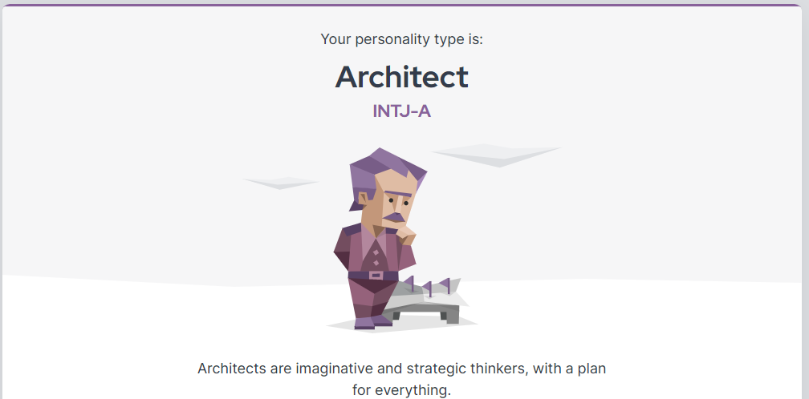
Appendix 2: Introverted Score
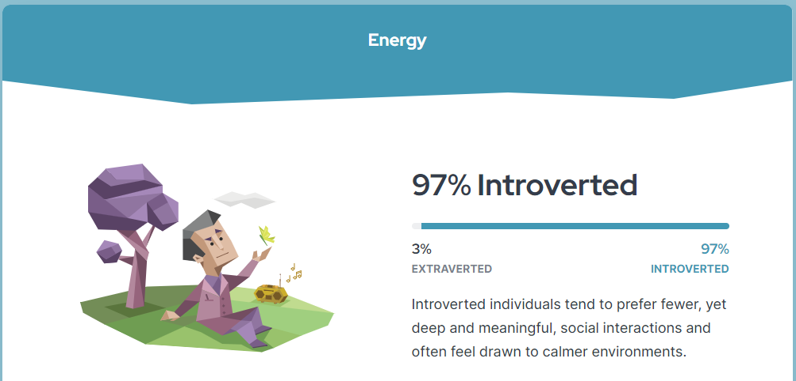
Appendix 3: Intuitive Score
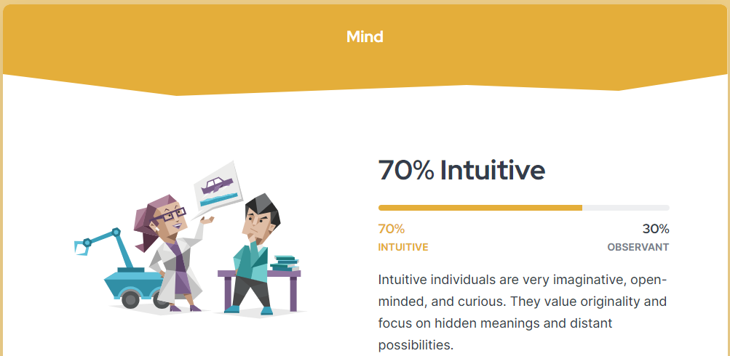
Appendix 4: Thinking Score
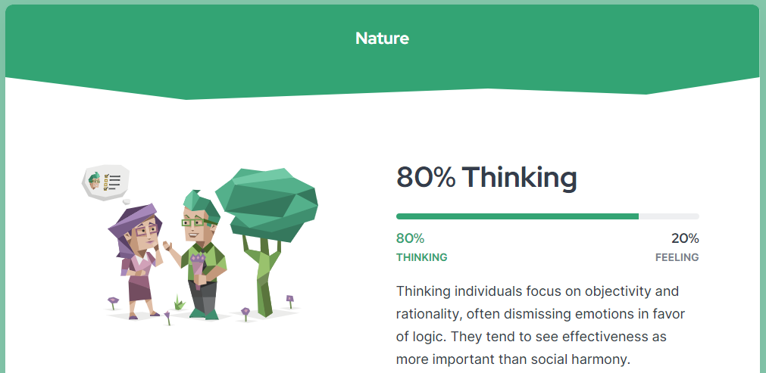
Appendix 5: Judging Score
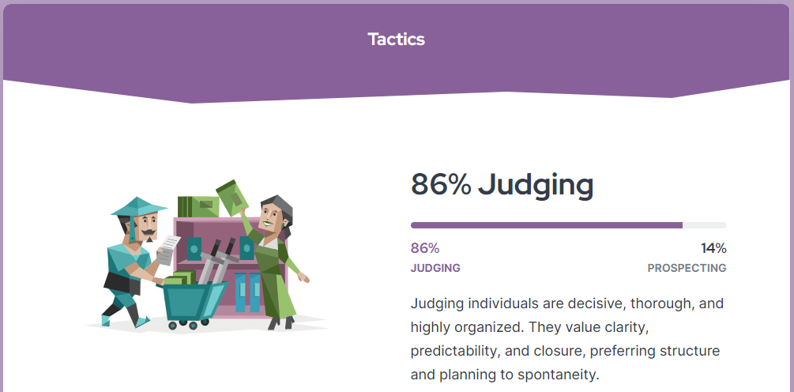
Appendix 6: Assertive Score
